# How can educational institutions help tackle the issue of urbanisation. An interview with Mr Hammad Noor AHMED from Superior University in Lahore | by ASEFEdu (Editor) | ASEFEdu (Blog) | Medium

# Name: Tahir Fareed

# Roll No: SU92-BSAIM-F24-036

# Section: BSAI (3A)

# Subject: AI Lab

# Task : 03

**Model Based Reflex Agent**

# Improved Documentation: ModelBasedReflexAgent

This document provides the improved documentation of the Python program implemented for a simple Model-Based Reflex Agent. The agent is designed to control the Air Conditioner (AC) based on room temperature.

## Flowchart

The following flowchart explains the working of the agent:

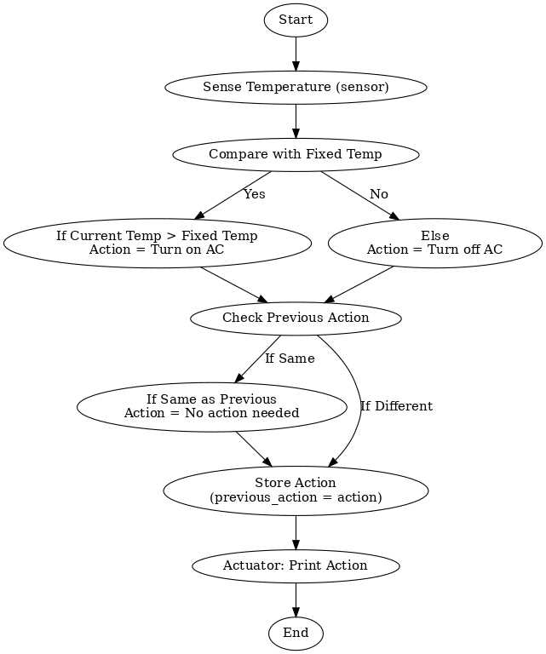

## Class Explanation

The `ModelBasedReflexAgent` class simulates an intelligent agent with the following functions:

1. __init__(self, temp): Initializes the agent with fixed temperature, previous action, and current temp.

2. sensor(self, temp): Updates current room temperature sensed by the agent.

3. performance(self): Determines the action (Turn on AC, Turn off AC, or No action needed).

4. actuator(self): Executes the chosen action and prints it.

## Example Usage

Rooms with their respective temperatures are defined. The agent decides the action for each room.

## Source Code

class ModelBasedReflexAgent:  
 def __init__(self, temp):   
 self.fixed_temp = temp  
 self.previous_action = None  
 self.current_temp = None  
   
 def sensor(self, temp):  
 self.current_temp = temp  
   
 def performance(self):  
 action = None  
 if self.current_temp > self.fixed_temp:  
 action = "Turn on the AC"  
 else:  
 action = "Turn off the AC"  
   
 if self.previous_action == action:  
 action = "No action needed"  
   
 self.previous_action = action  
 return action  
   
 def actuator(self):  
 action = self.performance()  
 print(f"{self.current_temp}°C => Action: {action}")  
  
  
# Example rooms  
rooms = {  
 "study Room": 20,  
 "bedroom Room": 18,  
 "Kitchen": 30,  
}  
  
agent = ModelBasedReflexAgent(22)   
  
for room, temp in rooms.items():  
 print(f"{room} :\t", end='')  
 agent.sensor(temp)  
 agent.actuator()  
  
print("\nExample of an individual room:")  
agent.sensor(24)  
agent.actuator()

**Screenshot:**

